September 2026

Upcoming Resurfacing Works – Woodhouse Lane Closure

Dear Customer,

We are writing to inform you of upcoming Resurfacing work that will be taking place in your area.

Where is the work?
The works will require a full road closure on Woodhouse Lane, Albrighton. A map is provided for reference.

When is this happening?
The works are scheduled from Monday 5th to Friday 9th October, between 8am and 5pm each day.
Please be aware that these dates may change due to weather or unforeseen circumstances. Any updates will be shown on local advance warning signs and on https://one.network/

How will this affect traffic?
A signed diversion route will be in place for the duration of the closure.

Will there be access to my property/business?
If you are looking to gain access to a property or business within the closure, we will provide access, however vehicle access may be restricted during working hours.

Our on‑site team will assist where possible. Our priority is to keep you and our staff safe however there may be delays or times when vehicle access cannot safely be provided.

During the work, access to the works area will be restricted to:
- Residents who live and reside within the road closure.
- Businesses located within the closure (if applicable)
- Emergency vehicles (blue light calls)

Where is the work?
Closure
Diversion
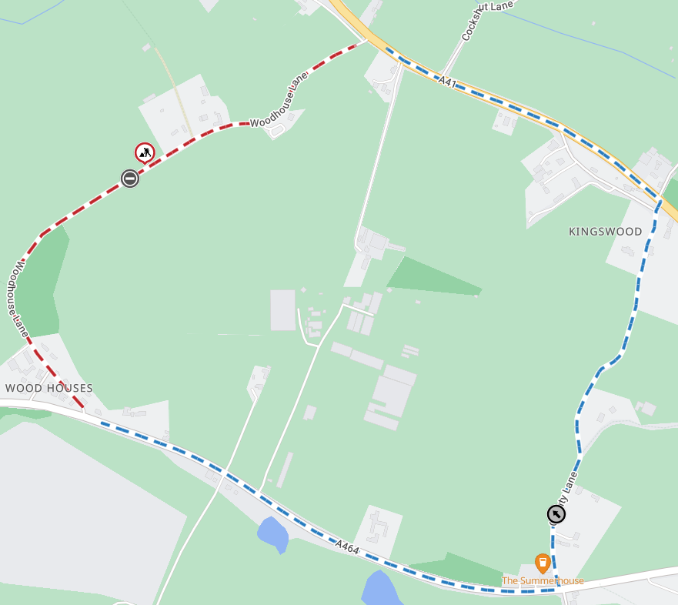
How can you help?
Please avoid parking on the road during working hours. This will help us complete the works efficiently and reduce disruption. If the access restrictions cause any difficulties, please speak to our team on site or contact us using the details below.

Find out more!
If you have any questions or would like to discuss the works, please contact Shropshire Council’s Highways Customer Services Centre on 0345 6789006.
Further information about roadworks in your area can be found at https://one.network/

Kind regards,
Shropshire Highways

